ДЗ6.Настройка репликации сегментов и мониторинга

Цель:
настроить репликацию сегментов и провести симуляцию отказа сегмента и восстановление системы, затем настроить систему мониторинга Greenplum.

Развёртывание и базовая конфигурация multi-node для проведения отказа сегмента
1.1. В Docker по инструкции добавлен образ и запущен контейнер с Greenplum DB с 3 сегментами.
https://t.me/c/2650491605/50
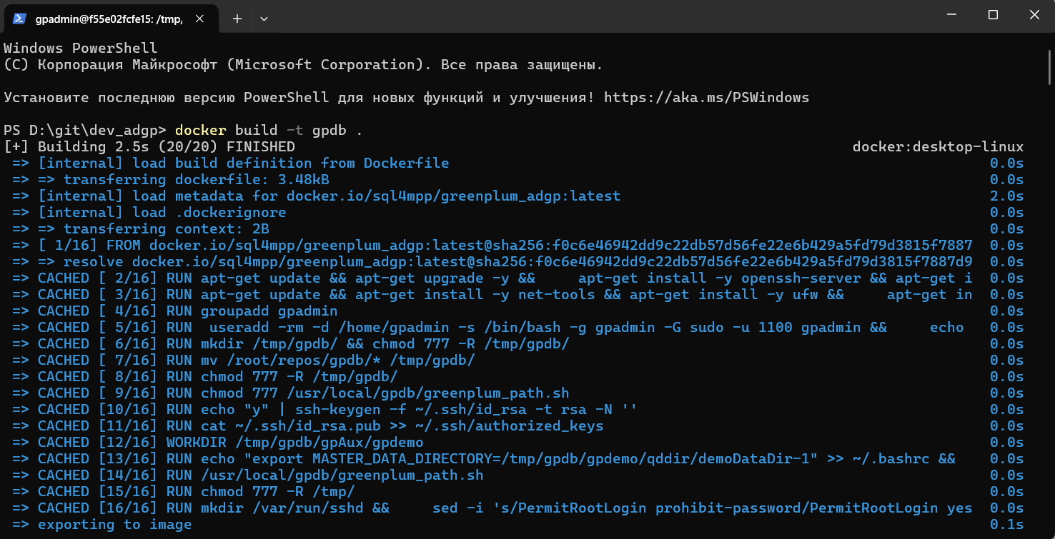
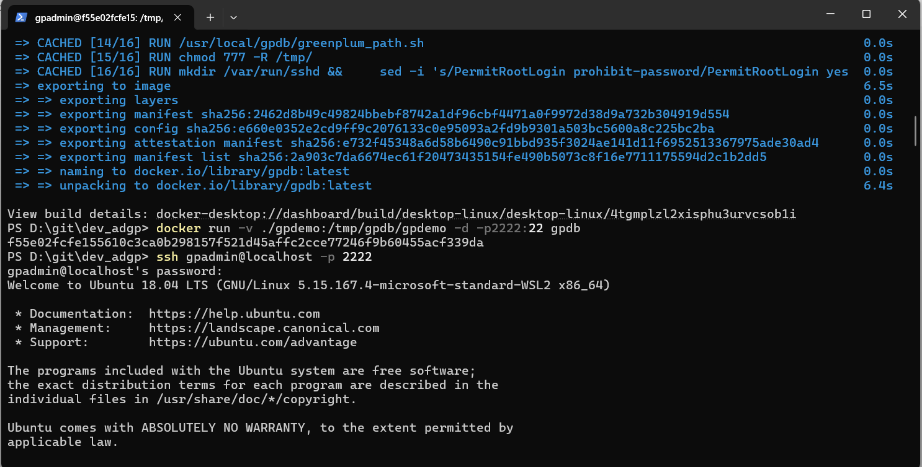
1.2. Выполнена сборка кластера предварительно пришлось додать права командой "chmod 777 -R /tmp/gpdb/" после запуска контейнера
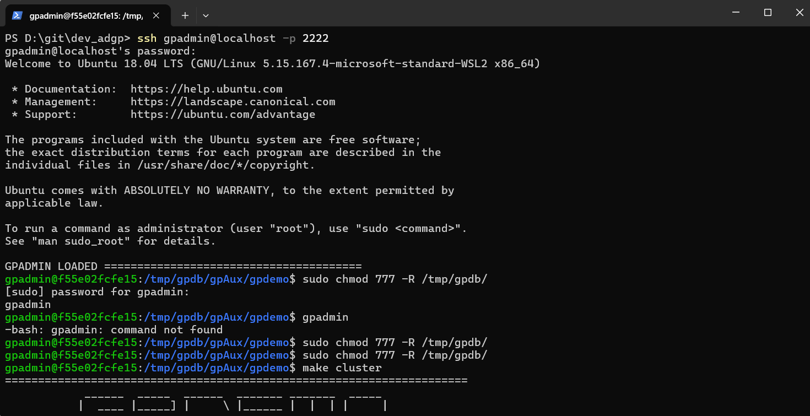
1.3. Запущен кластер
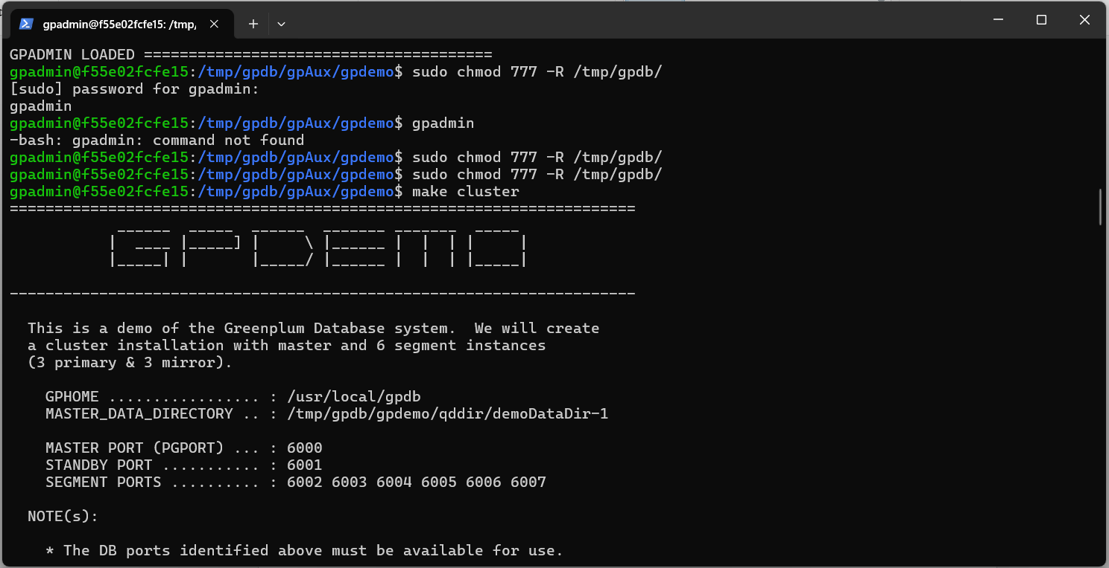
======================================================================
______ _____ ______ _______ _______ _____
| ____ |_____] | \ |______ | | | | |
|_____| | |_____/ |______ | | | |_____|

----------------------------------------------------------------------

This is a demo of the Greenplum Database system. We will create
a cluster installation with master and 6 segment instances
(3 primary & 3 mirror).

GPHOME ................. : /usr/local/gpdb
MASTER_DATA_DIRECTORY .. : /tmp/gpdb/gpdemo/qddir/demoDataDir-1

MASTER PORT (PGPORT) ... : 6000
STANDBY PORT ........... : 6001
SEGMENT PORTS .......... : 6002 6003 6004 6005 6006 6007

NOTE(s):

* The DB ports identified above must be available for use.
* An environment file gpdemo-env.sh has been created for your use.

======================================================================

rm: cannot remove '/tmp/gpdb/gpdemo': Device or resource busy
[f55e02fcfe15] rm: cannot remove '/tmp/gpdb/gpdemo': Device or resource busy
mkdir: cannot create directory '/tmp/gpdb/gpdemo': File exists
[f55e02fcfe15]
[f55e02fcfe15]
[f55e02fcfe15]
[f55e02fcfe15]
[f55e02fcfe15]
[f55e02fcfe15]
grep: clusterConfigPostgresAddonsFile: No such file or directory

======================================================================
CLUSTER_CONFIG_POSTGRES_ADDONS: clusterConfigPostgresAddonsFile
----------------------------------------------------------------------
fsync=off
======================================================================

==========================================================================================
executing:
/usr/local/gpdb/bin/gpinitsystem -a -c clusterConfigFile -l /tmp/gpdb/gpdemo/gpAdminLogs -p clusterConfigPostgresAddonsFile -s f55e02fcfe15 -P 6001 -S /tmp/gpdb/gpdemo/standby ""
==========================================================================================

20250703:19:00:35:000643 gpinitsystem:f55e02fcfe15:gpadmin-[INFO]:-Checking configuration parameters, please wait...
20250703:19:00:35:000643 gpinitsystem:f55e02fcfe15:gpadmin-[INFO]:-Reading Greenplum configuration file clusterConfigFile
20250703:19:00:35:000643 gpinitsystem:f55e02fcfe15:gpadmin-[INFO]:-Locale has not been set in clusterConfigFile, will set to default value
20250703:19:00:35:000643 gpinitsystem:f55e02fcfe15:gpadmin-[INFO]:-Locale set to en_US.utf8
20250703:19:00:35:000643 gpinitsystem:f55e02fcfe15:gpadmin-[INFO]:-No DATABASE_NAME set, will exit following template1 updates
20250703:19:00:35:000643 gpinitsystem:f55e02fcfe15:gpadmin-[INFO]:-MASTER_MAX_CONNECT not set, will set to default value 150
20250703:19:00:35:000643 gpinitsystem:f55e02fcfe15:gpadmin-[INFO]:-Detected a single host GPDB array build, reducing value of BATCH_DEFAULT from 60 to 4
20250703:19:00:35:000643 gpinitsystem:f55e02fcfe15:gpadmin-[WARN]:-Master open file limit is 1024 should be >= 65535
20250703:19:00:35:000643 gpinitsystem:f55e02fcfe15:gpadmin-[INFO]:-Master IP address array = 172.17.0.3
20250703:19:00:35:000643 gpinitsystem:f55e02fcfe15:gpadmin-[INFO]:-Standby IP address array = 172.17.0.3
20250703:19:00:35:000643 gpinitsystem:f55e02fcfe15:gpadmin-[WARN]:-Standby Master open file limit is 1024 should be >= 65535
20250703:19:00:35:000643 gpinitsystem:f55e02fcfe15:gpadmin-[INFO]:-Checking configuration parameters, Completed
20250703:19:00:35:000643 gpinitsystem:f55e02fcfe15:gpadmin-[INFO]:-Commencing multi-home checks, please wait...
.
20250703:19:00:35:000643 gpinitsystem:f55e02fcfe15:gpadmin-[INFO]:-Configuring build for standard array
20250703:19:00:35:000643 gpinitsystem:f55e02fcfe15:gpadmin-[INFO]:-Commencing multi-home checks, Completed
20250703:19:00:35:000643 gpinitsystem:f55e02fcfe15:gpadmin-[INFO]:-Building primary segment instance array, please wait...
...
20250703:19:00:35:000643 gpinitsystem:f55e02fcfe15:gpadmin-[INFO]:-Building group mirror array type , please wait...
...
20250703:19:00:36:000643 gpinitsystem:f55e02fcfe15:gpadmin-[INFO]:-Checking Master host
20250703:19:00:36:000643 gpinitsystem:f55e02fcfe15:gpadmin-[INFO]:-Checking new segment hosts, please wait...
20250703:19:00:36:000643 gpinitsystem:f55e02fcfe15:gpadmin-[WARN]:-Host f55e02fcfe15 open files limit is 1024 should be >= 65535
......20250703:19:00:36:000643 gpinitsystem:f55e02fcfe15:gpadmin-[WARN]:-Host f55e02fcfe15 open files limit is 1024 should be >= 65535

20250703:19:00:36:000643 gpinitsystem:f55e02fcfe15:gpadmin-[INFO]:-Checking new segment hosts, Completed
20250703:19:00:36:000643 gpinitsystem:f55e02fcfe15:gpadmin-[INFO]:-Building the Master instance database, please wait...
20250703:19:00:40:000643 gpinitsystem:f55e02fcfe15:gpadmin-[INFO]:-Starting the Master in admin mode
20250703:19:00:40:000643 gpinitsystem:f55e02fcfe15:gpadmin-[INFO]:-Commencing parallel build of primary segment instances
20250703:19:00:40:000643 gpinitsystem:f55e02fcfe15:gpadmin-[INFO]:-Spawning parallel processes batch [1], please wait...
...
20250703:19:00:40:000643 gpinitsystem:f55e02fcfe15:gpadmin-[INFO]:-Waiting for parallel processes batch [1], please wait...
...........
20250703:19:00:51:000643 gpinitsystem:f55e02fcfe15:gpadmin-[INFO]:------------------------------------------------
20250703:19:00:51:000643 gpinitsystem:f55e02fcfe15:gpadmin-[INFO]:-Parallel process exit status
20250703:19:00:51:000643 gpinitsystem:f55e02fcfe15:gpadmin-[INFO]:------------------------------------------------
20250703:19:00:51:000643 gpinitsystem:f55e02fcfe15:gpadmin-[INFO]:-Total processes marked as completed = 3
20250703:19:00:51:000643 gpinitsystem:f55e02fcfe15:gpadmin-[INFO]:-Total processes marked as killed = 0
20250703:19:00:51:000643 gpinitsystem:f55e02fcfe15:gpadmin-[INFO]:-Total processes marked as failed = 0
20250703:19:00:51:000643 gpinitsystem:f55e02fcfe15:gpadmin-[INFO]:------------------------------------------------
20250703:19:00:51:000643 gpinitsystem:f55e02fcfe15:gpadmin-[INFO]:-Removing back out file
20250703:19:00:51:000643 gpinitsystem:f55e02fcfe15:gpadmin-[INFO]:-No errors generated from parallel processes
20250703:19:00:51:000643 gpinitsystem:f55e02fcfe15:gpadmin-[INFO]:-Restarting the Greenplum instance in production mode
20250703:19:00:52:006317 gpstop:f55e02fcfe15:gpadmin-[INFO]:-Starting gpstop with args: -a -l /tmp/gpdb/gpdemo/gpAdminLogs -m -d /tmp/gpdb/gpdemo/qddir/demoDataDir-1
20250703:19:00:52:006317 gpstop:f55e02fcfe15:gpadmin-[INFO]:-Gathering information and validating the environment...
20250703:19:00:52:006317 gpstop:f55e02fcfe15:gpadmin-[INFO]:-Obtaining Greenplum Master catalog information
20250703:19:00:52:006317 gpstop:f55e02fcfe15:gpadmin-[INFO]:-Obtaining Segment details from master...
20250703:19:00:52:006317 gpstop:f55e02fcfe15:gpadmin-[INFO]:-Greenplum Version: 'postgres (Greenplum Database) 6.27.1_arenadata59+dev.1.gcbb3338b74 build dev'
20250703:19:00:52:006317 gpstop:f55e02fcfe15:gpadmin-[INFO]:-Commencing Master instance shutdown with mode='smart'
20250703:19:00:52:006317 gpstop:f55e02fcfe15:gpadmin-[INFO]:-Master segment instance directory=/tmp/gpdb/gpdemo/qddir/demoDataDir-1
20250703:19:00:52:006317 gpstop:f55e02fcfe15:gpadmin-[INFO]:-Stopping master segment and waiting for user connections to finish ...
server shutting down
20250703:19:00:53:006317 gpstop:f55e02fcfe15:gpadmin-[INFO]:-Attempting forceful termination of any leftover master process
20250703:19:00:53:006317 gpstop:f55e02fcfe15:gpadmin-[INFO]:-Terminating processes for segment /tmp/gpdb/gpdemo/qddir/demoDataDir-1
20250703:19:00:54:006562 gpstart:f55e02fcfe15:gpadmin-[INFO]:-Starting gpstart with args: -a -l /tmp/gpdb/gpdemo/gpAdminLogs -d /tmp/gpdb/gpdemo/qddir/demoDataDir-1
20250703:19:00:54:006562 gpstart:f55e02fcfe15:gpadmin-[INFO]:-Gathering information and validating the environment...
20250703:19:00:54:006562 gpstart:f55e02fcfe15:gpadmin-[INFO]:-Greenplum Binary Version: 'postgres (Greenplum Database) 6.27.1_arenadata59+dev.1.gcbb3338b74 build dev'
20250703:19:00:54:006562 gpstart:f55e02fcfe15:gpadmin-[INFO]:-Greenplum Catalog Version: '301908232'
20250703:19:00:54:006562 gpstart:f55e02fcfe15:gpadmin-[INFO]:-Starting Master instance in admin mode
20250703:19:00:55:006562 gpstart:f55e02fcfe15:gpadmin-[INFO]:-Obtaining Greenplum Master catalog information
20250703:19:00:55:006562 gpstart:f55e02fcfe15:gpadmin-[INFO]:-Obtaining Segment details from master...
20250703:19:00:55:006562 gpstart:f55e02fcfe15:gpadmin-[INFO]:-Setting new master era
20250703:19:00:55:006562 gpstart:f55e02fcfe15:gpadmin-[INFO]:-Master Started...
20250703:19:00:55:006562 gpstart:f55e02fcfe15:gpadmin-[INFO]:-Shutting down master
20250703:19:00:57:006562 gpstart:f55e02fcfe15:gpadmin-[INFO]:-Commencing parallel segment instance startup, please wait...
20250703:19:00:58:006562 gpstart:f55e02fcfe15:gpadmin-[INFO]:-Process results...
20250703:19:00:58:006562 gpstart:f55e02fcfe15:gpadmin-[INFO]:-----------------------------------------------------
20250703:19:00:58:006562 gpstart:f55e02fcfe15:gpadmin-[INFO]:- Successful segment starts = 3
20250703:19:00:58:006562 gpstart:f55e02fcfe15:gpadmin-[INFO]:- Failed segment starts = 0
20250703:19:00:58:006562 gpstart:f55e02fcfe15:gpadmin-[INFO]:- Skipped segment starts (segments are marked down in configuration) = 0
20250703:19:00:58:006562 gpstart:f55e02fcfe15:gpadmin-[INFO]:-----------------------------------------------------
20250703:19:00:58:006562 gpstart:f55e02fcfe15:gpadmin-[INFO]:-Successfully started 3 of 3 segment instances
20250703:19:00:58:006562 gpstart:f55e02fcfe15:gpadmin-[INFO]:-----------------------------------------------------
20250703:19:00:58:006562 gpstart:f55e02fcfe15:gpadmin-[INFO]:-Starting Master instance f55e02fcfe15 directory /tmp/gpdb/gpdemo/qddir/demoDataDir-1
20250703:19:00:58:006562 gpstart:f55e02fcfe15:gpadmin-[INFO]:-Command pg_ctl reports Master f55e02fcfe15 instance active
20250703:19:00:58:006562 gpstart:f55e02fcfe15:gpadmin-[INFO]:-Connecting to dbname='template1' connect_timeout=15
20250703:19:00:58:006562 gpstart:f55e02fcfe15:gpadmin-[INFO]:-No standby master configured. skipping...
20250703:19:00:58:006562 gpstart:f55e02fcfe15:gpadmin-[INFO]:-Database successfully started
20250703:19:00:58:000643 gpinitsystem:f55e02fcfe15:gpadmin-[INFO]:-Completed restart of Greenplum instance in production mode
20250703:19:00:58:000643 gpinitsystem:f55e02fcfe15:gpadmin-[INFO]:-Commencing parallel build of mirror segment instances
20250703:19:00:58:000643 gpinitsystem:f55e02fcfe15:gpadmin-[INFO]:-Spawning parallel processes batch [1], please wait...
...
20250703:19:00:58:000643 gpinitsystem:f55e02fcfe15:gpadmin-[INFO]:-Waiting for parallel processes batch [1], please wait...
....
20250703:19:01:02:000643 gpinitsystem:f55e02fcfe15:gpadmin-[INFO]:------------------------------------------------
20250703:19:01:02:000643 gpinitsystem:f55e02fcfe15:gpadmin-[INFO]:-Parallel process exit status
20250703:19:01:02:000643 gpinitsystem:f55e02fcfe15:gpadmin-[INFO]:------------------------------------------------
20250703:19:01:02:000643 gpinitsystem:f55e02fcfe15:gpadmin-[INFO]:-Total processes marked as completed = 3
20250703:19:01:02:000643 gpinitsystem:f55e02fcfe15:gpadmin-[INFO]:-Total processes marked as killed = 0
20250703:19:01:02:000643 gpinitsystem:f55e02fcfe15:gpadmin-[INFO]:-Total processes marked as failed = 0
20250703:19:01:02:000643 gpinitsystem:f55e02fcfe15:gpadmin-[INFO]:------------------------------------------------
20250703:19:01:02:000643 gpinitsystem:f55e02fcfe15:gpadmin-[INFO]:-Starting initialization of standby master f55e02fcfe15
Operation: Cannot import modules. Please check that you have sourced greenplum_path.sh. Detail: No module named yaml
20250703:19:01:02:000643 gpinitsystem:f55e02fcfe15:gpadmin-[WARN]:-Non-fatal issue with standby master initialization, check gpstate -f output
20250703:19:01:02:000643 gpinitsystem:f55e02fcfe15:gpadmin-[INFO]:-Scanning utility log file for any warning messages
20250703:19:01:02:000643 gpinitsystem:f55e02fcfe15:gpadmin-[WARN]:-*******************************************************
20250703:19:01:02:000643 gpinitsystem:f55e02fcfe15:gpadmin-[WARN]:-Scan of log file indicates that some warnings or errors
20250703:19:01:02:000643 gpinitsystem:f55e02fcfe15:gpadmin-[WARN]:-were generated during the array creation
20250703:19:01:02:000643 gpinitsystem:f55e02fcfe15:gpadmin-[INFO]:-Please review contents of log file
20250703:19:01:02:000643 gpinitsystem:f55e02fcfe15:gpadmin-[INFO]:-/tmp/gpdb/gpdemo/gpAdminLogs/gpinitsystem_20250703.log
20250703:19:01:02:000643 gpinitsystem:f55e02fcfe15:gpadmin-[INFO]:-To determine level of criticality
20250703:19:01:02:000643 gpinitsystem:f55e02fcfe15:gpadmin-[WARN]:-*******************************************************
20250703:19:01:02:000643 gpinitsystem:f55e02fcfe15:gpadmin-[INFO]:-Greenplum Database instance successfully created
20250703:19:01:02:000643 gpinitsystem:f55e02fcfe15:gpadmin-[INFO]:-------------------------------------------------------
20250703:19:01:02:000643 gpinitsystem:f55e02fcfe15:gpadmin-[INFO]:-To complete the environment configuration, please
20250703:19:01:02:000643 gpinitsystem:f55e02fcfe15:gpadmin-[INFO]:-update gpadmin .bashrc file with the following
20250703:19:01:02:000643 gpinitsystem:f55e02fcfe15:gpadmin-[INFO]:-1. Ensure that the greenplum_path.sh file is sourced
20250703:19:01:02:000643 gpinitsystem:f55e02fcfe15:gpadmin-[INFO]:-2. Add "export MASTER_DATA_DIRECTORY=/tmp/gpdb/gpdemo/qddir/demoDataDir-1"
20250703:19:01:02:000643 gpinitsystem:f55e02fcfe15:gpadmin-[INFO]:- to access the Greenplum scripts for this instance:
20250703:19:01:02:000643 gpinitsystem:f55e02fcfe15:gpadmin-[INFO]:- or, use -d /tmp/gpdb/gpdemo/qddir/demoDataDir-1 option for the Greenplum scripts
20250703:19:01:02:000643 gpinitsystem:f55e02fcfe15:gpadmin-[INFO]:- Example gpstate -d /tmp/gpdb/gpdemo/qddir/demoDataDir-1
20250703:19:01:02:000643 gpinitsystem:f55e02fcfe15:gpadmin-[INFO]:-Script log file = /tmp/gpdb/gpdemo/gpAdminLogs/gpinitsystem_20250703.log
20250703:19:01:02:000643 gpinitsystem:f55e02fcfe15:gpadmin-[INFO]:-To remove instance, run gpdeletesystem utility
20250703:19:01:02:000643 gpinitsystem:f55e02fcfe15:gpadmin-[INFO]:-Standby Master f55e02fcfe15 has been configured
20250703:19:01:02:000643 gpinitsystem:f55e02fcfe15:gpadmin-[INFO]:-To activate the Standby Master Segment in the event of Master
20250703:19:01:02:000643 gpinitsystem:f55e02fcfe15:gpadmin-[INFO]:-failure review options for gpactivatestandby
20250703:19:01:02:000643 gpinitsystem:f55e02fcfe15:gpadmin-[INFO]:-------------------------------------------------------
20250703:19:01:02:000643 gpinitsystem:f55e02fcfe15:gpadmin-[INFO]:-The Master /tmp/gpdb/gpdemo/qddir/demoDataDir-1/pg_hba.conf post gpinitsystem
20250703:19:01:02:000643 gpinitsystem:f55e02fcfe15:gpadmin-[INFO]:-has been configured to allow all hosts within this new
20250703:19:01:02:000643 gpinitsystem:f55e02fcfe15:gpadmin-[INFO]:-array to intercommunicate. Any hosts external to this
20250703:19:01:02:000643 gpinitsystem:f55e02fcfe15:gpadmin-[INFO]:-new array must be explicitly added to this file
20250703:19:01:02:000643 gpinitsystem:f55e02fcfe15:gpadmin-[INFO]:-Refer to the Greenplum Admin support guide which is
20250703:19:01:02:000643 gpinitsystem:f55e02fcfe15:gpadmin-[INFO]:-located in the /usr/local/gpdb/docs directory
20250703:19:01:02:000643 gpinitsystem:f55e02fcfe15:gpadmin-[INFO]:-------------------------------------------------------
========================================
gpinitsystem returned: 1
========================================

======================================================================
OPTIMIZER STATE
----------------------------------------------------------------------
Optimizer state .. : on
======================================================================

version
------------------------------------------------------------------------------------------------------------------------------------------------------------------------------------------------------------
PostgreSQL 9.4.26 (Greenplum Database 6.27.1_arenadata59+dev.1.gcbb3338b74 build dev) on x86_64-unknown-linux-gnu, compiled by gcc (Ubuntu 7.3.0-16ubuntu3) 7.3.0, 64-bit compiled on Jan 1 2025 23:04:39
(1 row)

optimizer
-----------
on
(1 row)

gp_opt_version
---------------------------------------------
GPOPT version: 4.0.0, Xerces version: 3.1.2
(1 row)

======================================================================

1.4.Проверка статуса сегментов
- из Dbeaver
select *
from gp_segment_configuration
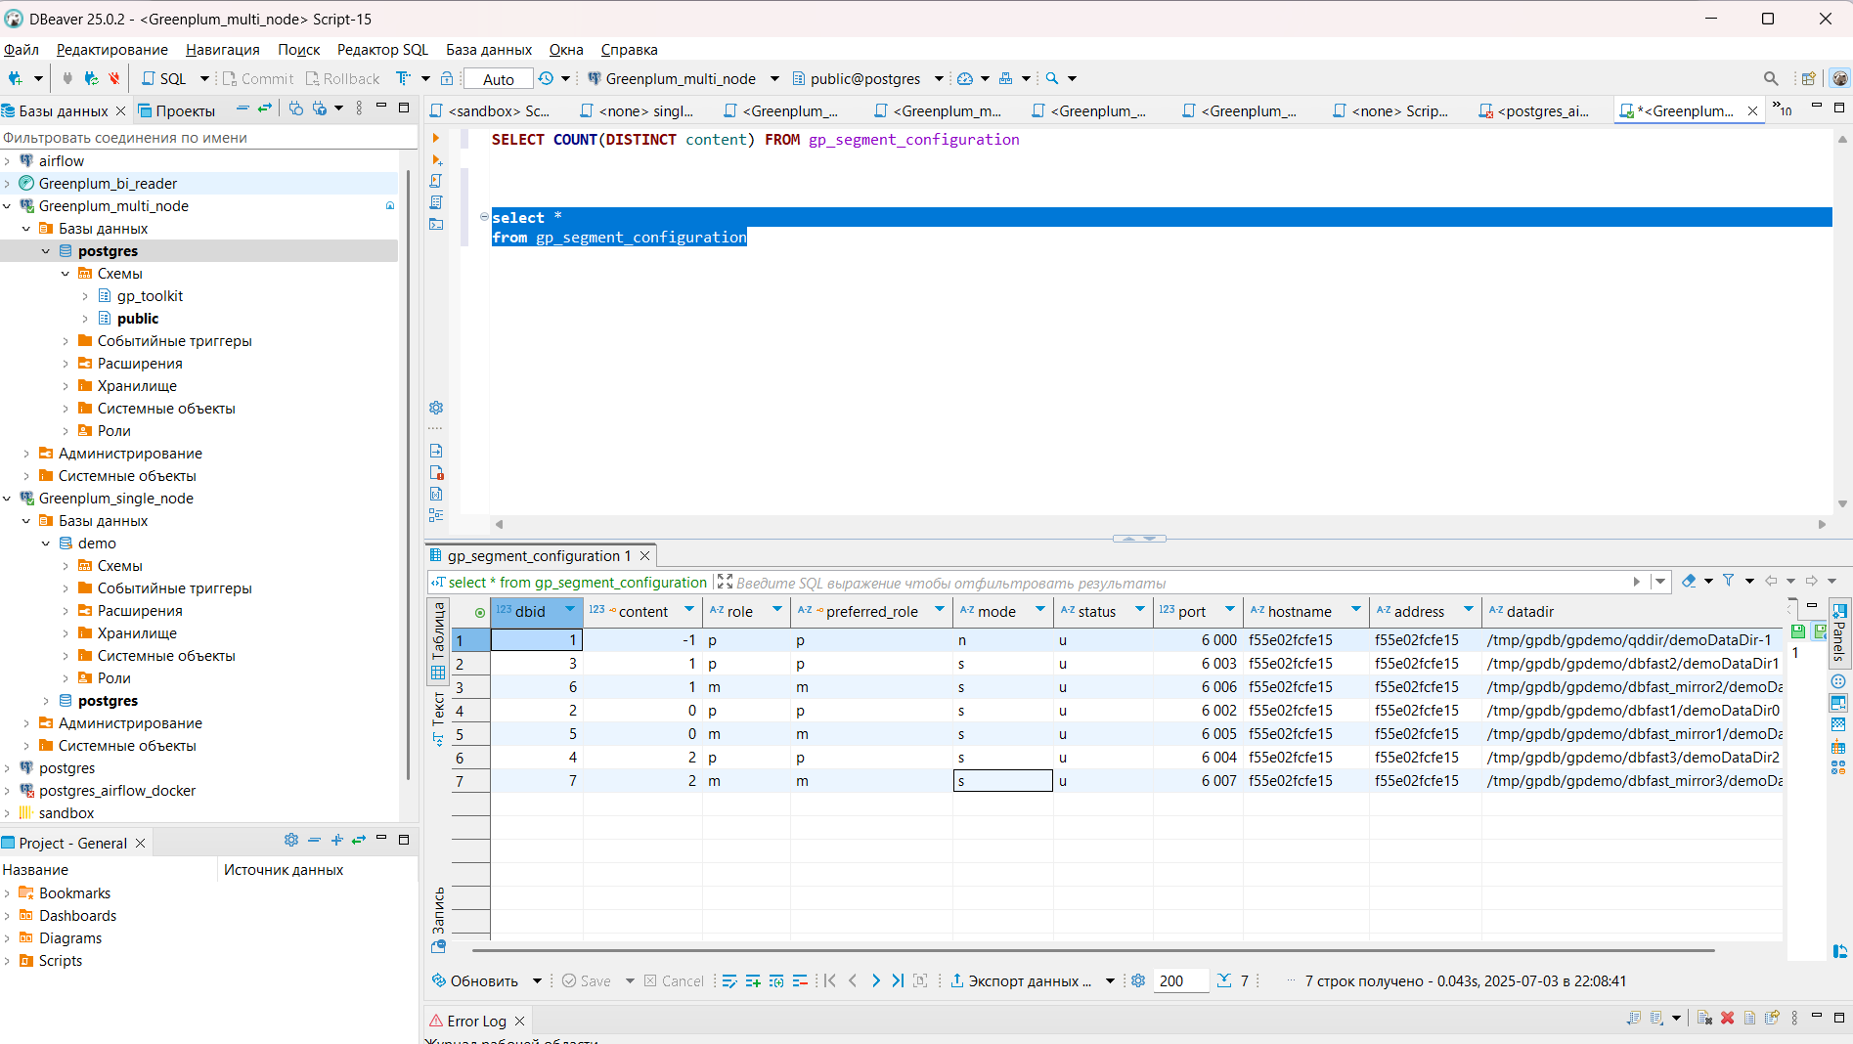
- Командой gpstate -e
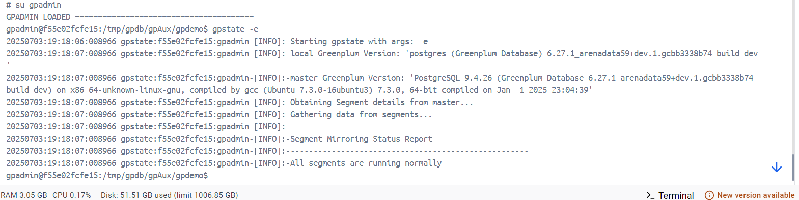
Все сегменты работают нормально

2. Симуляция отказа сегмента и восстановление системы

Остановила произвольный сегмент
/usr/local/gpdb/bin/pg_ctl stop -m fast -D /tmp/gpdb/gpdemo/dbfast3/demoDataDir2/
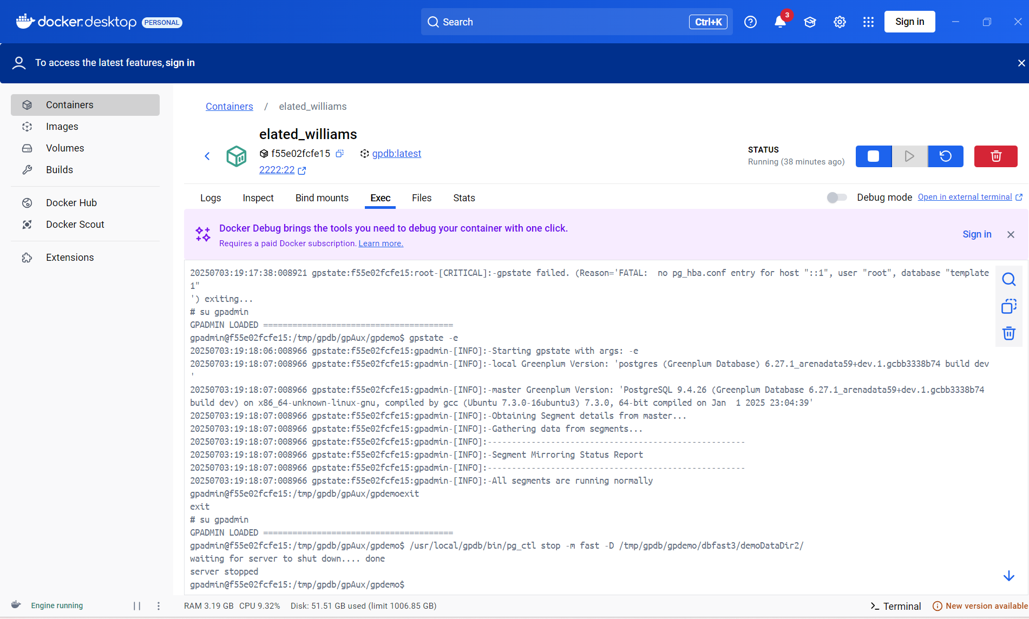

Проверила состояния сегментов из DBeaver
У остановленного сегмента статус “d” – недоступен

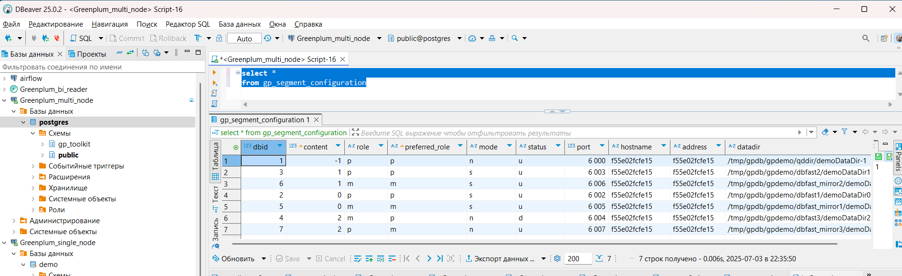

Включила сегмент
/usr/local/gpdb/bin/pg_ctl start -D /tmp/gpdb/gpdemo/dbfast3/demoDataDir2/

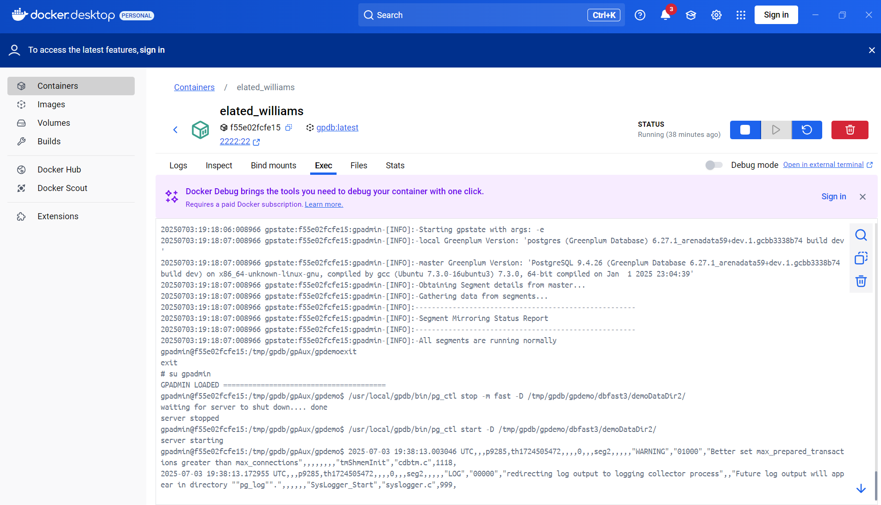
Статусы сегментов не изменились
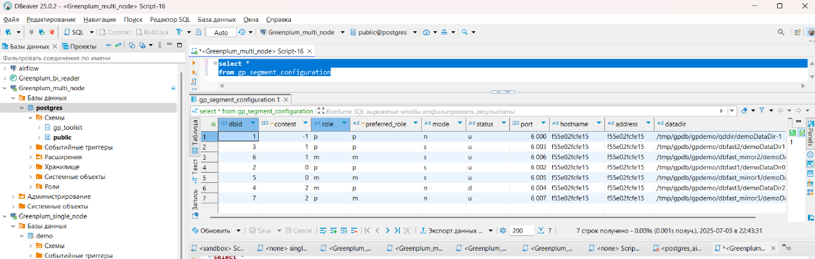

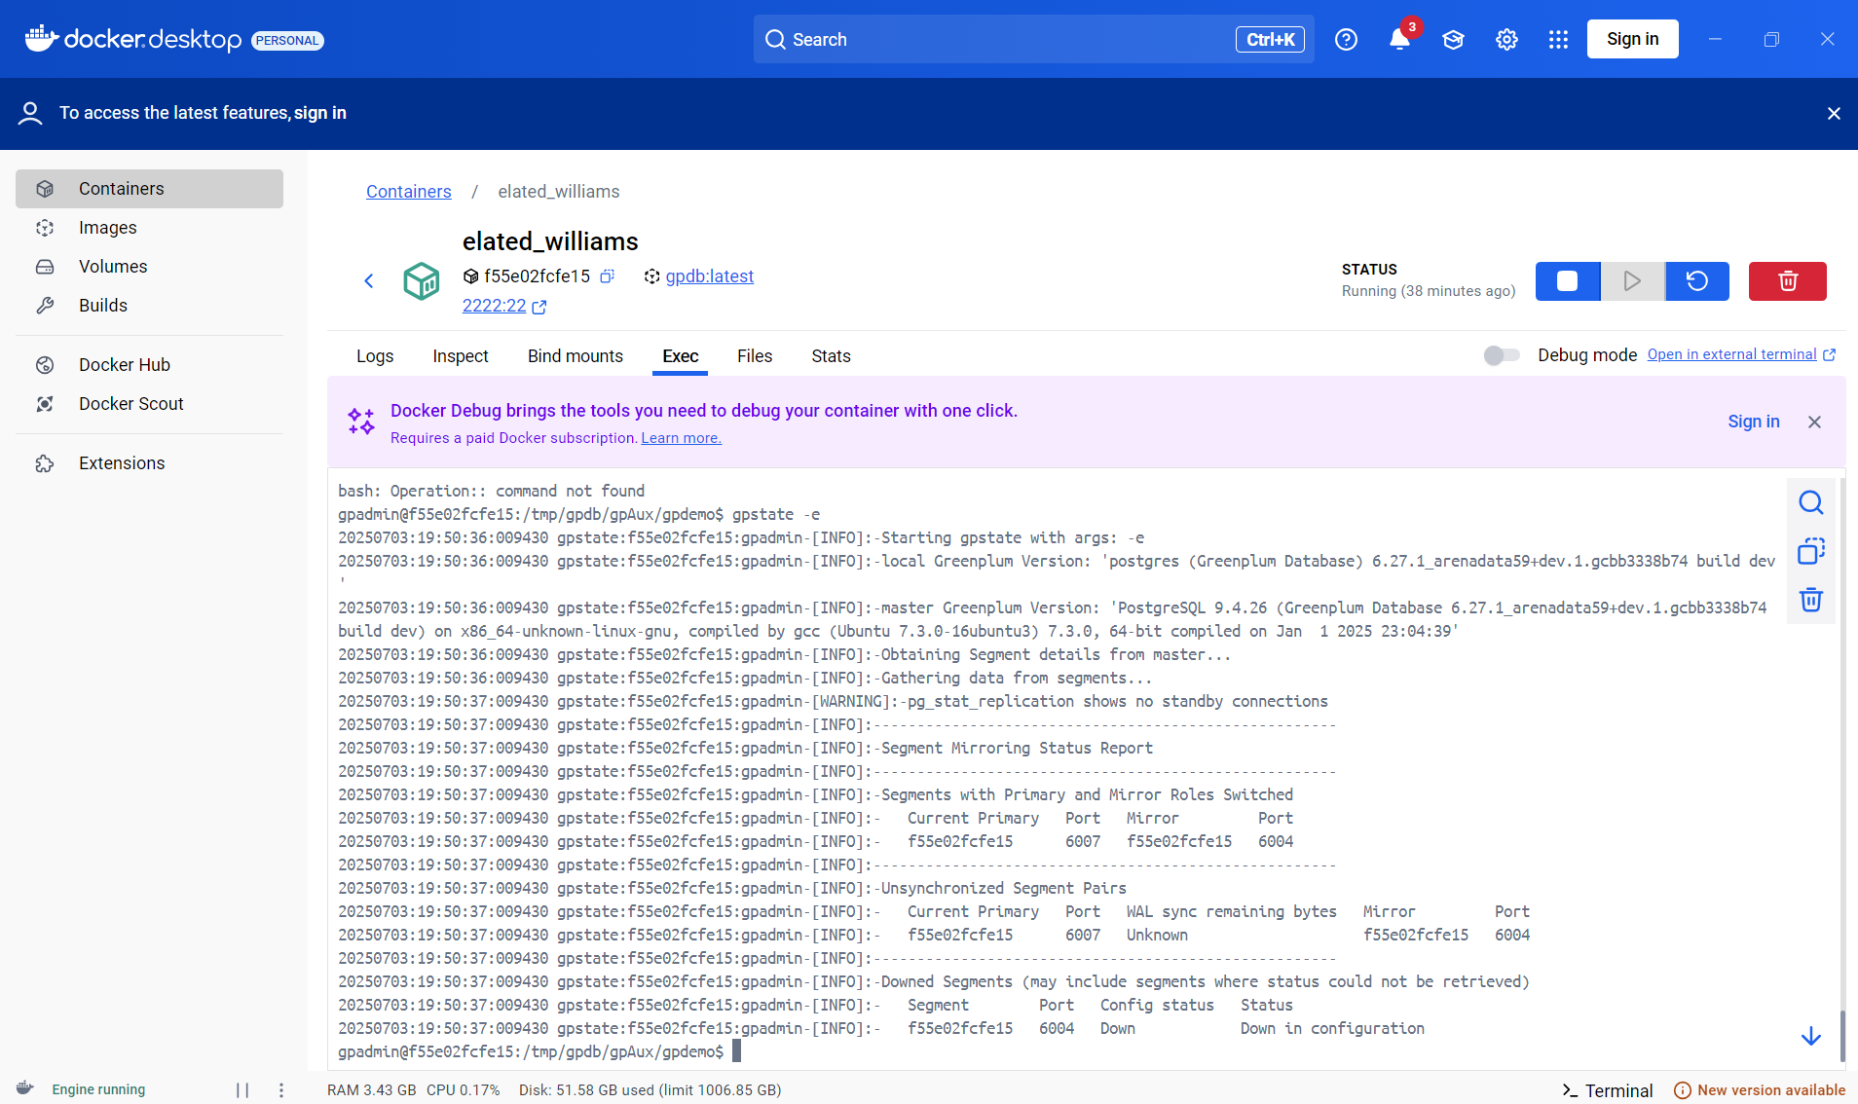

Запустила процесс рекавера

gprecoverseg –F

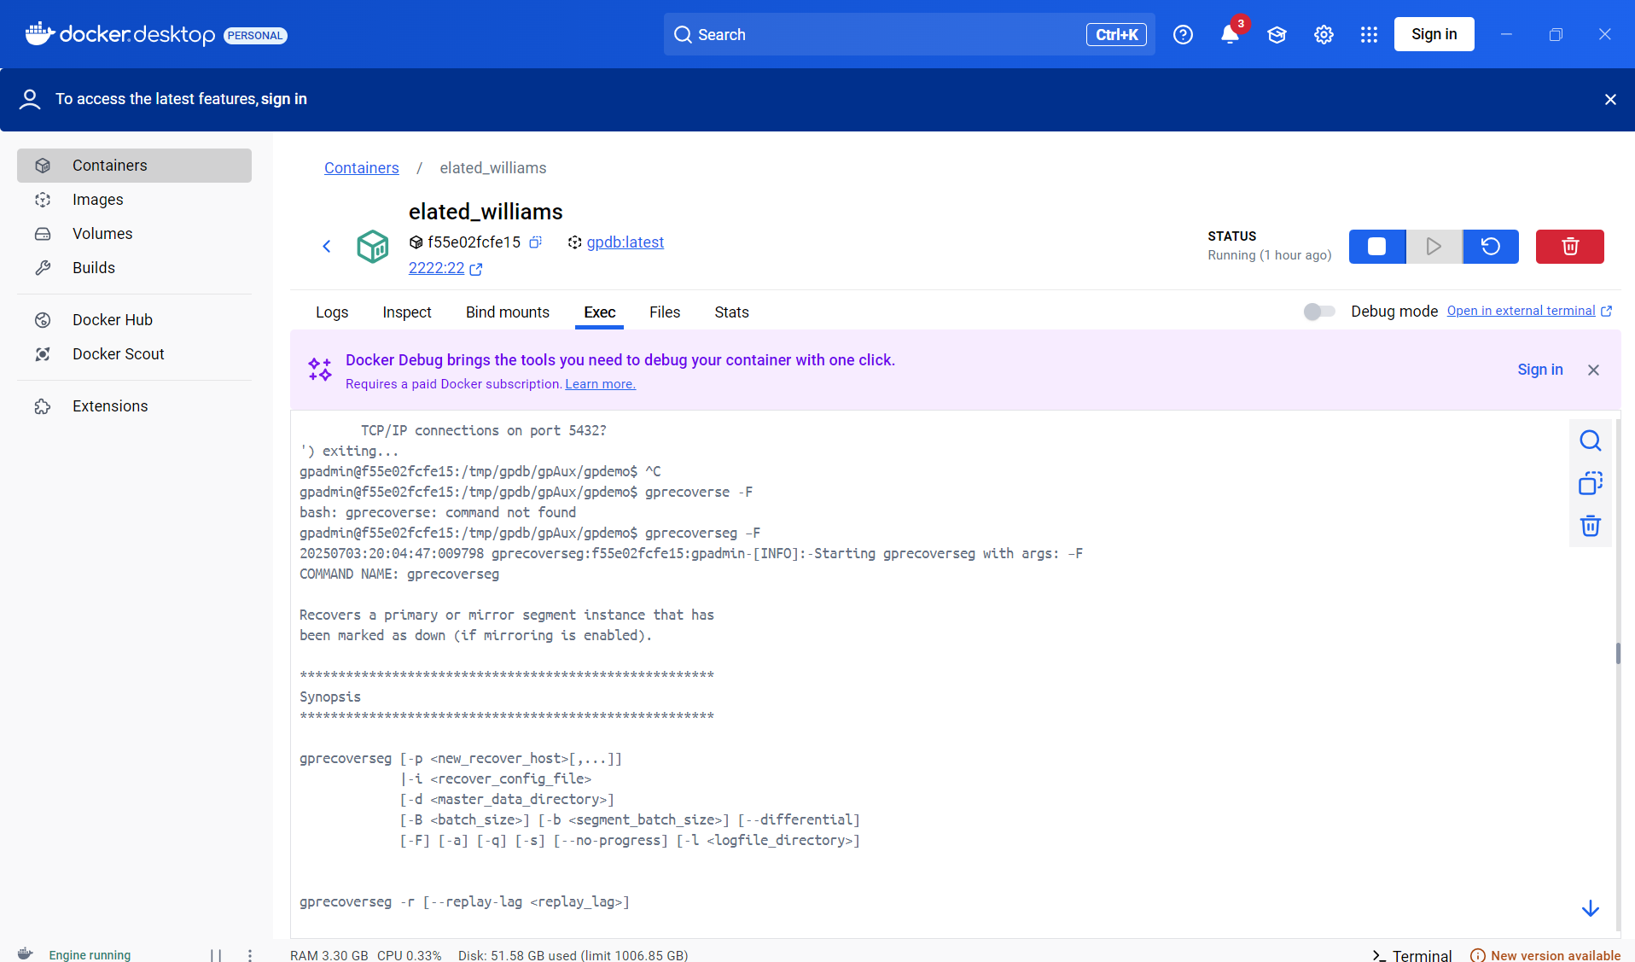

Выполнила ребаланс
gprecoverseg -r

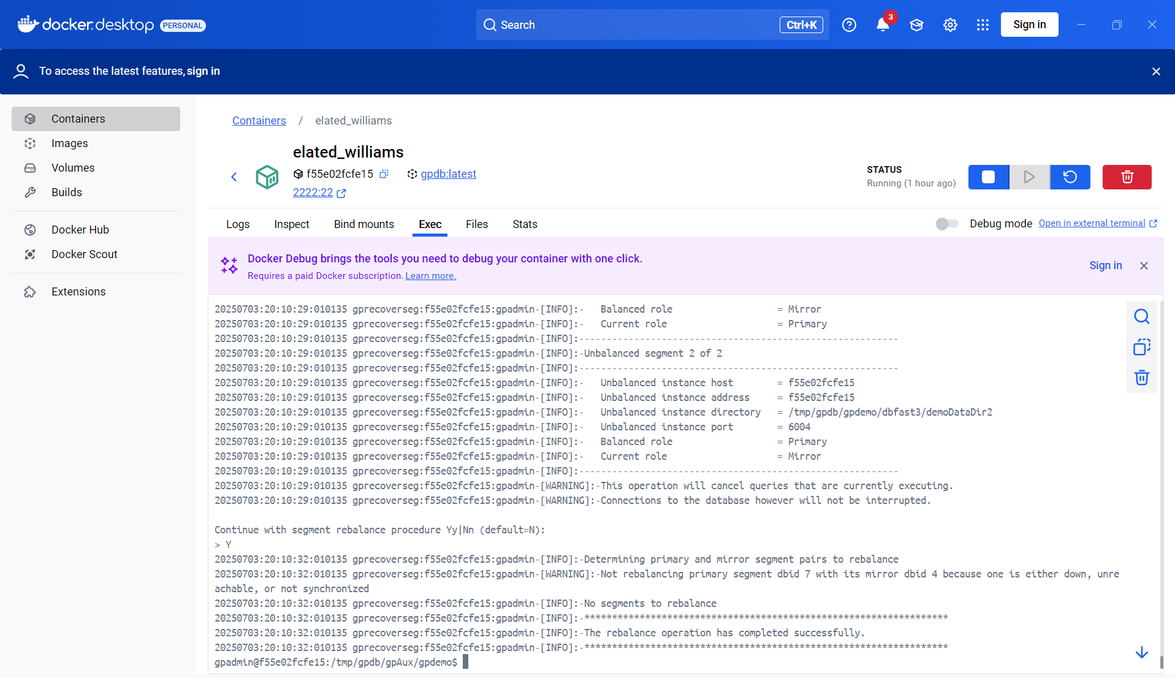

Проверила состояния сегментов - все сегменты работают нормально
gpstate -e